

CMPT 276 – Group 01 – Glucinators

Assignment 2 – Requirements Document

Website: <https://sites.google.com/view/cmpt276-summer2018/>

Anmol Bajaj

Faisal Atif

Zhixin Huang

Tony Liu

Henry Yip

June 22th, 2018

**1. Table of Contents**

**Table of Contents2**

**Revision History3**

**Introduction4**

**Intended Audience List5**

Tech-savvy Seniors within Canada 5

Intended Audience Globally 6

Pregnant Women with Gestational Diabetes 6

People with prediabetes 7

Professional athletes 7

**Features and Functional Requirements8**

Feature 19

Feature 210

Feature 311

Feature 412

Feature 513

Feature 614

Feature 715

Feature 816

Feature 917

Feature 1018

Feature 1119

**Non-functional Requirements20**

**Example Scenarios21**

Logging blood glucose level21

View long term glucose trend in form of graph22

Add dietary diary entry with pictures and tags23

Exporting data to PDF24

Application Onboarding25

**Glossary26**

**Citation27**

**2. Revision History**

|  |  |  |  |
| --- | --- | --- | --- |
| **Revision** | **Status** | **Publication/Revision Date** | **By** |
| 0.0 | Rough draft created with requirement for each category | June 11, 2018 | Henry Yip |
| 1.0 | Design document created | June 15, 2018 | Everyone |
| 1.1 | Added rough writing with each part | June 15, 2018 | Henry Yip |
| 1.2 | Assigned sections of plan for each group members | June 15, 2018 | Everyone |
| 2.0 | Added “Introduction” & “Intended Audience List” | June 17, 2018 | Everyone |
| 2.1 | Added “Features” | June 17, 2018 | Anmol Bajaj |
| 3.0 | Added more “Features” | June 18, 2018 | Tony Liu |
| 3.1 | Added “Non-functional Requirements” | June 18, 2018 | Faisal Atif |
| 3.2 | Added “Example Tutorial” | June 18, 2018 | Everyone |
| 3.3 | Added “Glossary” | June 19. 2018 | Tony Liu |
| 4.0 | Modified the report | June 20, 2018 | Everyone |
| 4.1 | Formatted the file | June 22, 2018 | Zhixin Huang |

**3. Introduction**

The mobile application EasyGlucose by Glucinators will provide a seamless blood glucose tracking experience for the diabetic community on an iOS phone or tablet. The core fundamental services that EasyGlucose will provide include[*]:

1. Recording blood glucose data from any blood glucose meter.
2. Provide a health analysis of the recorded data and present results graphically on a timeline.
3. Allow users to log their meal diary with pictures, events, tags, and personal notes.
4. Exporting a health report to a printable PDF file and sending it as an email.

For those with diabetes, it is absolutely essential for them to be able to track their blood sugar levels and share them with medical professionals for analyzation and consultation. The application is advantageous to accelerate the consultation process because of its smooth and straightforward recording and exporting features.

In addition, personal meal diaries with pictures, events, tags, and notes significantly expands the scope of captured data for health professionals. User’s reaction to foods, portions, and supplementary information may help users pinpoint sources of causality and general health trends.

Lastly, EasyGlucose will emphasize on ease-of-use and an intuitive design to encourage and simplify usability as the app’s main target audience is the elderly population, where diabetes is most prevalent. It will also include multilingual support to capture a wider market. An aesthetic timeline graph with meal pictures integrated seamlessly will serve as portal to viewing the specific entries of the diary. It will also encourage users to use the app more often because of its inviting appearance, simple learning curve, and minimal clutter.

.

[*] Footnote: a complete, detailed, and exhaustive features list is provided on page XX

**4. Intended Audience List**

EasyGlucose aims to promote and develop a healthy community. The target audience is the population who suffer from diabetes (Type 1, Type 2, and gestational) and hope to find a way to manage it, track it, and improve their health.

The audience scope is not limited by age. However, this application will be developed with the intention of simple use for the elderly people. The application will be easy to use and shall not require more than 10 minutes of training for an average elderly user to be able to use it to its full potential, thus minimal experience with a mobile application is required.

In greater Vancouver, the two of the most dominant languages include English and Chinese. In response to this, our app will be available in both the English and Chinese (simplified) language to include the Chinese speaking population.

**1) Tech-savvy Seniors within Canada**

The intended audience for EasyGlucose grows everyday as the senior population of Canada grows to be more tech-savvy and familiar with smartphones. With the Senior’s increasing appetite for longevity and healthy-living, we aim to make our application the “go-to” app for tracking blood glucose. Today’s seniors are more willing to learn and adapt to new technology. They may not have much experience, however, their willingness to learn is high when where there is an “ecosystem of support” [1] around them. We aim to personalize our app and guide them every step of the way. We assume that their goal is to enhance their standard of living.

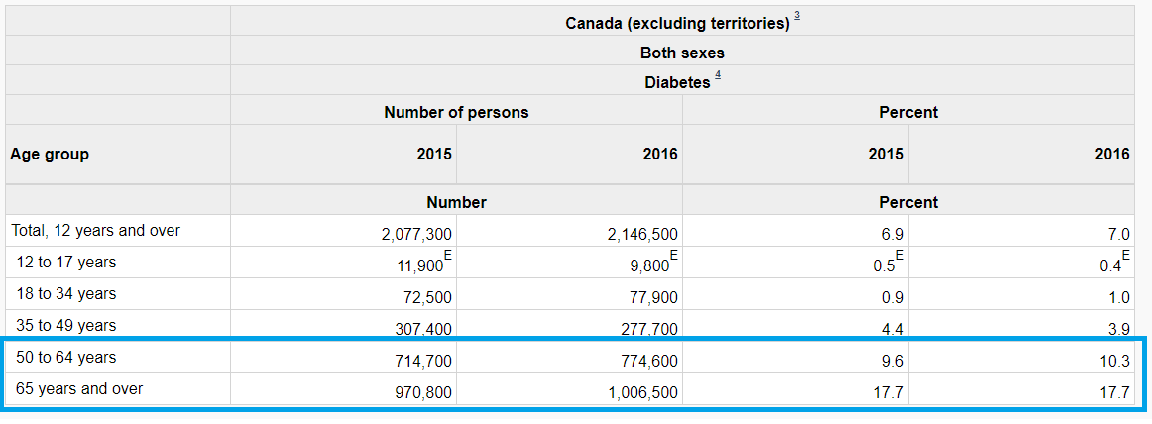

Figure1.a: Highlighted age group is our primary audience and also the largest proportion of population with diabetes [2]

**2) Intended Audience Globally**

The desire for health management apps, and specifically for diabetes management app is a worldwide phenomenon. With year over year of increasing demand, we believe that the comprehensive logging and analytical features of EasyGlucose is primed to meet the goals of a worldwide audience.

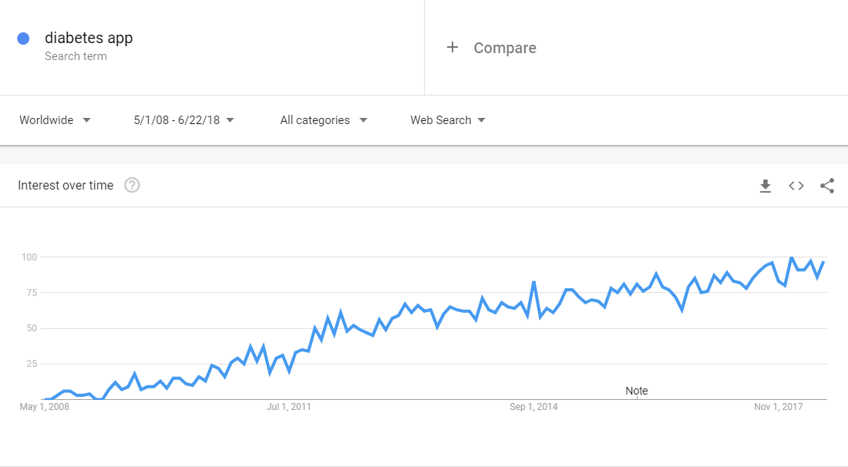

Figure 1.b Worldwide searches for the term “diabetes app” on Google Trends [3]

**3) Pregnant Women with Gestational Diabetes**

We assume that this is the first pregnancy for the pregnant women with gestational diabetes. They are inexperienced with gestational diabetes and need a comprehensive set of intuitive features to guide them in their journey. They are on the younger side of the diabetic population, with most of them being in the ages 20-40. These women are extremely concerned about the harm that high levels of gestational diabetes can cause to their baby. They are millenials, and thus, familiar with smartphones apps to a confident degree. Their goal is to manage their gestational diabetes, track any uncertainties, and to make sure that their blood glucose levels remain within the physician recommended levels.

**4) People with prediabetes**

The people with prediabetes are highly self-conscious of their health and lifestyle choices. They are younger, much more familiar with technology, and extremely motivated to track their blood sugar on a daily basis. Their goal is to prevent prediabetes from becoming type-2 diabetes. We assume that they will use our “Report” feature a lot, as they generally have physicians and dietitians to help them navigate out of the prediabetes phase.

**5) Professional athletes**

This is an extremely small subset of population. However, there is a huge opportunity in having popular, professional athletes use EasyGlucose. Professional athletes could potentially act as Brand Ambassadors for our application and promote the ease of use on their public social media accounts.

We assume that they need to track their blood glucose levels on a very regular basis due to intense training regimes. Professional athletes also have experienced dietitians and physicians who need to able to access the athlete’s blood glucose information on a regular basis. We assume that they are quick to learn new iOS apps. They are also familiar with the idea of tracking blood glucose and the benefits it entails. Their goal is to stay within the range of their optimum glucose levels so they can fulfill their goal of performing at their best ability.

**5. Features and Functional Requirements**

EasyGlucose will offer the following services as application features:

Core features:

1. Blood glucose level measurement entry (via touch screen and voice) and storage.
2. Dietary log entry with pictures, tags, events, and personal notes.
3. Production and illustration of scalable timeline graphs containing glucose measurements and log entries.

Utility features:

1. Application home screen with navigation option to other features.
2. Scrollable blood glucose level entry table and diary entry table.
3. Blood glucose level analysis with mean and deviations.
4. Printable PDF exporting of health data and report.
5. Sharing health report via email to dietitians and health professionals.

Customization and personalization features:

1. User profile initialization.
2. User profile display and modification.
3. System settings

**Feature 1: Blood Glucose measurement entries via Keyboard and Voice**

Feature description:

* The purpose of this feature is to allow the user to store their blood glucose level measurements in the local SQLite database. This will be the most frequently used feature. As a result, it is our focus to make this feature as quick and easy to use as possible. With regards to display of entries, the user will be able to view the entries as a graph (feature 3), and through an editable detailed table (feature 5).

Functional requirements:

1. All entry fields for the glucose measurement entry must be located within in same screen.
2. Each blood glucose entry should include the following data:

* Blood glucose level
* System built-in tag related to the entry (e.g.: before dinner, after workout, etc)
* Date and time of measurement

1. The user should have the option to input the entry fields in requirement 2 through the touchscreen with each field following a specific input method listed below:
   1. Blood glucose measurement should be inputted by the on-board keyboard.
   2. The current time and date should display as an entry for this field by default; however, users are able to edit the time and date by scrolling the entry subfields (month/date/hour/minute).
   3. The tag field should be a drop down menu containing a list of pre-entered tags, with the last tag being “custom tag”.
      1. If user chooses “custom tag”, a new text field will appear for the tag entry. This entry should be completed by use of on-board keyboard.
2. The user should have the option to input the entry fields in requirement 2 by voice input.
   1. If the user chose to input by voice, they must be able to verify the correctness of the entry content through a editable text box.
   2. If the user chose to input by voice, they must be able edit the content presented requirement 4.1, with the edited entry being saved instead of initial voice input entry.
3. After filling up all the entry fields, the user must be able to save the entry to a local database by press of 1 button.

**Feature 2: Dietary log entries with pictures, tags, events, and personal notes.**

Feature description:

* The purpose of this feature is to allow the user to store their diary log entries in the local SQLite database. This feature is intended to be frequently used, as a result, it must be quick and easy to use. With regards to display of entries, the user will be able to view the entries in feature 3 as a graph, and be able to view entries in detail and edit them through feature 5

Functional requirements:

1. The user should be able to complete the diary text and tag entry in 1 scrollable screen
2. The user should be able to complete the diary picture entry in 1 screen that is different from requirement 1.
3. Each diary entry must contain a subject title, diary entry body, and associated tags. If the user chose to fill these using touch screen, they should be able to fill each field according to methods listed below
   1. The subject title should be inputted by on-board keyboard.
   2. The diary entry body should be inputted by on-board keyboard .
   3. The associated tags should be inputted by a drop down menu of pre-entered tags, with last tag being “custom tag”
      1. If user choose “custom tag”, a new text field will appear for the tag entry. This entry should be completed by use of on-board keyboard.
   4. The user should be able to add multiple tags by tapping a “+” button located beside the last added tag.
4. The diary subject and body should also have the option to be inputted by voice.
   1. If the user chose to input by voice, they must be able to verify the correctness of the entry content through a editable text box.
   2. If the user chose to input by voice, they must be able edit the content presented requirement 4.1, with the edited entry being saved instead of initial voice input entry.
5. The picture entry should be initiated by pressing a “Add picture” button, which gives the user the option to choose an existing image from system image gallery, or take a new image with on on-board camera.
6. After filling up the desired entry fields, the user must be able to save the entry in local database in press of 1 button.

**Feature 3: Production and illustration of scalable timeline graphs containing glucose measurements and log entries.**

Feature description:

* This feature will provide user a graphical representation of their blood glucose trend over the selected time period. The graph produced will also include toggleable dietary diary entries in the form of bubble for ease of access.

Functional requirements:

1. A graph showing glucose measurement over a default time period of 30 days should be shown when the user first enters the graph illustration screen.
2. The user should be able to use the expand or pinch gesture to scale the time period of the displayed data.
3. The user should be able to see a different period of selected time frame by dragging the graph to the left or to the right.
4. There should be a toggle button located at the top of the screen to display or hide diary entry bubbles.
5. Toggling on the “show diary entries” button will display circular bubbles with thumbnails of diary entry pictures on the graph.
   1. The user should be able to view the specific entry by tapping on the bubble.
   2. The bubbles will be displayed either above or below the produced graph.
   3. The horizontal position of the bubbles should align to the date/time the the referenced entry is made.
   4. If bubbles are overlapped, the overlapped bubbles should disappear from the graph. These overlapped bubbles should reappear on the graph once their projected location is no longer overlapped.
6. The user should have the option to manually select time period to be displayed by using a drop down option menus.
7. The user should be able to filter graph data by the following criterias, which are selected from a drop down menu.
   1. Only show data where diary entries were entered on the same day.
   2. Only show data where measurement were above or below certain limit.
      1. The user should be able to enter the numeric limit using built-in keyboard.
8. Actions applied to the graph must have no effect on any saved data.

**Feature 4: Application home screen with navigation options to other features.**

Feature description:

* This feature will serve as the home screen for EasyGlucose. All of the core features, and some of the utility features will be accessible from this screen. As the user will see the home screen every time they open the app, the home screen must be unclustered and aesthetically pleasing.

Functional requirement:

1. The app should be directed to this screen upon loading, except when opening the app for the first time, where a preliminary survey will load instead.
2. This screen must have large buttons labeled:
   1. “Enter glucose level”
   2. “Enter dietary diary entry”
   3. “Display glucose level trend”
   4. “Export printable document”
      1. There will be a “?” bubble beside this button. Tapping this bubble will show a pop-up describing the what this feature does. The pop-up will disappear after being tapped
   5. “Send report as Email”
   6. “System settings”
   7. “Profile settings”
   8. Upon touching any of the aforementioned buttons, the application should redirect the user to the corresponding screen.
3. The home screen should not be visually clustered and must not have overlapping visual elements.
4. There must be a minimum distance of 50 pixels between boundaries of buttons.

**Feature 5: Scrollable blood glucose level entry table and diary entry table.**

Feature description:

* These two tables will allow the user to view and edit previously entered glucose level measurements and diary entries.

Functional requirements:

1. 2 selectable tabs labeled “glucose level entry” and “diary entry” will be located above the scrollable table.
   1. Tapping the “glucose level entry” tab should replace the content in the scrollable table with past glucose level entries.
   2. Tapping the “diary entry” tab should the replace the content in the scrollable table with past dietary diary entries.
2. The glucose level entry table should have the option to be sorted by ascending or descending order for value of glucose measurement, and by ascending or descending order for date measured.
3. The diary entry table should have the option to be sorted by ascending or descending order for date entered, alphabetical order by subject title, alphabetical order by tag.
   1. The diary entry table should also have the option to filter entries by tag.
4. Each entry on the entry table should be shown as a horizontal rectangular bar.
   1. Tapping on the rectangular bar will lead to the specific entry page.

**Feature 6: Blood glucose level analysis.**

Feature description:

* The application will generate and record the mean blood glucose level for each month and extract specific dates of outlying blood glucose levels. This data is stored to be used in the health report PDF.

Functional requirements:

1. The application will generate the mean blood glucose level for each month, beginning on the first day of each month until the day before the next month, and record it within the local database.
   1. There will also be separate mean calculations for all blood glucose levels tagged before or after a meal.
   2. For the concurrent month, the mean will be updated at the end of every day, with the range from the first day of the month to the current day.
2. The date of deviating glucose levels that significantly exceed the average for an “after-meal” or “before meal” blood glucose level will be recorded in the local database. The formula to detect dangerous levels is as follows[*]:
   1. Calculate the standard deviation for “after-meal” and “before-meal”
      1. S = √∑((xi – µ)2/(N – 1))

Where xi each blood glucose measurement “before-meal” (or “after”)

µ is the mean of “before-meal” (or “after”)

N is the total number of measurements used

* 1. Let the average blood glucose be µ

Let the current blood glucose be Y

If Y ≥ X+S

Notify the user that this is an abnormal level of blood sugar and to consider seeking medical help

[*] Footnote: calculation is subject to change upon review

**Feature 7: Printable PDF exporting of health data and report.**

Feature description:

* This feature will allow the user to export their blood glucose measurement data as a viewable PDF document. The goal of this feature is to simplify the process of consulting medical professionals by providing comprehensive glucose level data. The produced document in this case, will focus on being comprehensive while remaining well formatted.

Functional requirements:

1. Upon opening the PDF export feature, the user should be presented with a default export option, which should export the document with the following settings.
   1. The document will be present in portrait mode.
   2. The document will contain a glucose measurement graph containing measurements in the last 30 days.
   3. The document will contain a table that contain glucose measurement recorded in the time period presented in the graph. This table will contain a date/time column and a measurement column.
2. The user should have the option to present the document in landscape or portrait mode through a drop down selection menu.
3. The user should have the option to select the graph time frame selection by applying a pinching or expanding motion on the graph.
4. The user should have the option to fine-tune the graph time frame option by selecting the time frame through a drop down menu. This drop down menu will contain pre-entered timeframe options of 30 days, past 3 months, past 6 months, past year, and all time.
5. The width of the produced graph should be half that of the page if the user chose landscape mode. The width of the produced graph should be the same as the distance between the left and right margins.
6. The glucose measurement table should contain measurements within the same time frame displayed by the selected graph.

**Feature 8: Sharing health report via email to dietitians and health professionals.**

Feature description:

* This feature will allow the user to select and send their previously generated health report, which is attached to a message body entry.

Functional requirements:

1. Upon opening of this Email feature, the user should be presented with a list of exported PDF documents.
2. The user should be able to select one of the previously exported document as an attachment for the Email to be sent.
3. After selecting the desired document, the user will be redirected to the iOS Email service, where an empty Email with the selected document as attachment is created.
4. After returning to the app, the user should be presented to the home screen.

**Feature 9: User profile initialization.**

Feature description:

* The profile initialization will be used to gather information required to provide analysis for glucose measurements. This feature will only launched when opening the app for the first time.

Functional requirements:

1. The user profile initialization should be only initiated when opening EasyGlucose for the first time.
2. Upon opening EasyGlucose for the first time, the user should be presented with a series of questionnaire screens which ask for the user to enter their date of birth, height, weight, biological sex, and type of diabetes, in the respective order. The method of input will be as follows
   1. Date of birth will be entered using drop down menu with month, day and year fields
   2. height, weight, will be entered using numeric keyboard entries
   3. Biological sex and type of diabetes will be entered using circular selection options.
3. Each questionnaire screen should ask the user to enter 1 required information.
4. The user should not proceed to the next screen unless they have inputted the required information on the current screen.
5. There should be a “return to previous button” on each of the questionnaire.
   1. Tapping this button will allow the user to return to the previous questionnaire and modify their answer.
6. All of the information entered should be saved to the local database as entries in the user profile.
   1. All of the information entered must only be saved after all questionnaires are complete.

**Feature 10: User profile display and modification.**

Feature description:

* The profile display and modification will allow the user to view and modify their entries entered for the user profile initialization.

Functional requirements:

1. The profile settings should display the following profile page informations that are entered by the user: date of birth, weight, height, biological sex, and type of diabetes.
2. The profile settings should allow the user to change the above mentioned informations based on methods as follows:
   1. Date of birth will be entered using drop down menu with month, day and year fields
   2. Height and weight, will be entered using numeric keyboard entries
   3. Biological sex and type of diabetes will be entered using circular selection options.
3. The profile settings should have a button labeled “Save settings”, where upon tapping this button, all the user information that are modified will replace the current entries in the local database.
4. The original profile settings entries in the database should not be modified unless the “Save settings” button is pressed.

**Feature 11: System settings.**

Feature description:

* This feature will allow the user to modify various functional and aesthetics elements of EasyGlucose based to the user’s preference.

Functional requirements:

The system settings will have the following setting options:

1. Glucose measurement reminder settings listed below. These options are selectable from a drop down menu.
   1. Remind me 12 hours after the last measurement.
   2. Remind me 24 hours after the last measurement.
   3. Never remind me.
2. Changing the system language to the following, which are shown from a drop down selection menu.
   1. English
   2. Chinese (simplified)
3. Unit of measurement for displaying glucose levels, weight and height. The options are as follows:
   1. Metric units
   2. Imperial units
   3. Glucose measurement in mmol/L (millimoles per litre) or mg/dL (milligrams per decilitre)

**6. Non-functional requirements**

The design of EasyGlucose does not impose significant performance concerns. As a result the developers should focus more on improving usability and convenience. The following list of non-functional requirements are written with the aforementioned objective in mind, and will serve as useful guidelines in the development process. Also, the order of this list has no relation to the priority of each listed requirement.

1. The complete app should not crash under regular use.
2. There must be no unintended loss of data that has been previously saved by the user under regular legitimate use or when the app crashes.
3. The app must be compatible with all current (June 2018) officially supported[4] iPhone devices.
4. The app must comply with the App Store guidelines [5]
5. Glucose measurement data saved by the user must be saved locally on the device.
6. The user interface must be visually unclustered with 0 overlapping on screen elements
7. The app should be easy to learn and use.
   1. The average user should take less than 10 minutes to learn how to user the core function of EasyGlucose
   2. The average user should not make more than 5 errors when using any core feature of EasyGlucose
8. The analysis of glucose measurements must be clinically correct.
9. If the the app is unable to give correct analysis, the app must not issue message that will lead the user to harm themselves.
10. The PDF export time of glucose measurement data within the timeframe of 6 months should complete under 10 seconds.
11. The format of PDF export document should be visually unclustered with 0 overlapping word or images.
12. The local database for the app should not have any unused entries.
13. All user information must be available without an internet connection.
14. Glucose measurement data, tags, pictures, notes, and user information saved by the user must be stored locally on the device and be retained for as long as it is not deleted by the user, or unless the device itself is compromised.
15. Internet connection must be attained before the user is able to use the email function of the app.

**7. Example Scenarios**

**Use case:** Logging blood glucose level.

1. To save a glucose level entry, the user will travel to the EasyGlucose home screen by swiping right. Once the user reached the home screen, they will locate a click a large button named “Enter glucose level”. (see figure 1)
2. The user is then directed to the glucose entry screen where the following data entry fields are shown as in the figure 2. The data entry fields correspond to figure 2, containing the following:
   1. Glucose level (keyboard/voice input)
   2. Time of entry
3. The user will enter their measured glucose level in data entry field (a) using either keyboard or by voice input.
4. If the user want to record the current time as time of entry, they don’t have to modify the “Time of entry” option. Simply tap “Save entry” to complete the glucose level entry.
5. If the user want to record a different time as time of entry, they must select the “another time” option from the drop down menu (b). The screen will be modified to the 3rd figure if the user chooses to do so.
6. After choosing “another time”, the user will enter the time of entry according to the drop down menu options and tap “Save entry” to complete the glucose level entry.

Figure 1 Figure 2 Figure 3

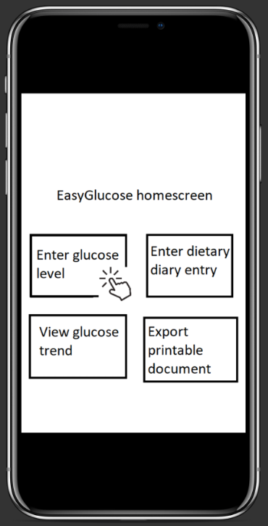

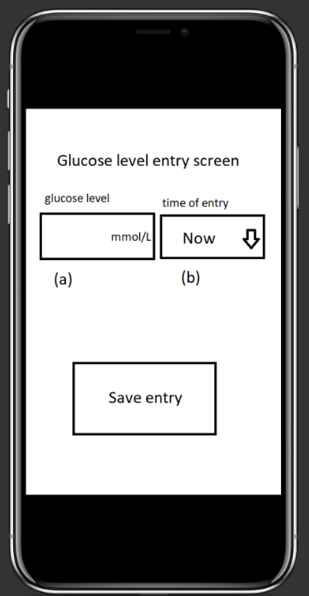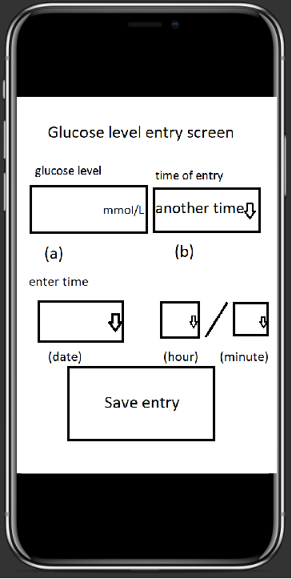

**Use case:** View long term glucose trend in form of graph.

1. To view the long term glucose trend, the user need to travel to the EasyGlucose home screen by swiping right. Once the user reached the home screen, they will locate a click a large button named “View glucose trend”. (see figure 1)
2. The user will be directed to the graph displaying screen, where a graph showing glucose measurement for the last 30 days is displayed by default. (see figure 2)
3. If the user want to see different period of default time frame (30 days), they can drag the graph to the left or to the right to reach their desired time frame.
4. If the user want to view the graph in a different time frame, they can modify the time frame by pinching or expanding the graph by a two finger gesture.
5. On the graph viewing screen, there will be a button on the top right corner named “show diary”. (see figure 2) Selecting this button will show bubbles on the graph, which contain pictures of diary entries entered by the user. These bubbles will be located vertically aligned with their date of entry. (see figure 3)
6. The user can tap the bubble to view their diary entry.
7. The user can swipe left to return to the EasyGlucose home screen.

Figure 1 Figure 2 Figure 3 (diary is toggled)

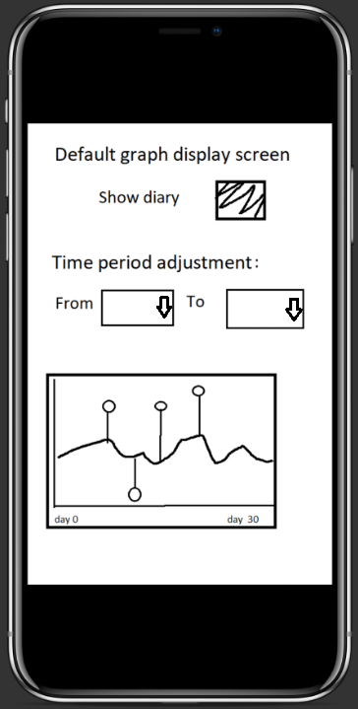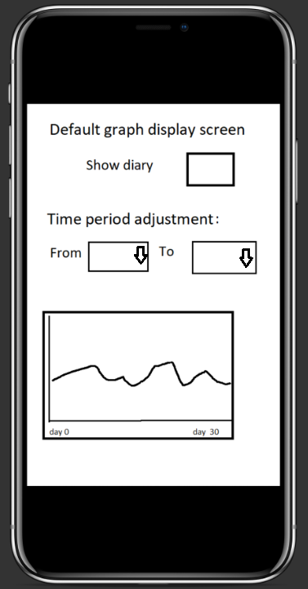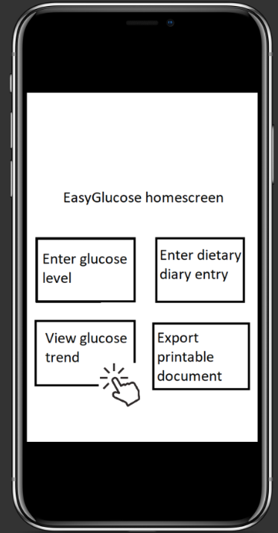

**Use case:** Add dietary diary entry with pictures and tags.

1. To add a dietary diary entry, the user need to travel to the EasyGlucose home screen by swiping right. Once the user reached the home screen, they will locate and click a large button named “Enter dietary diary entry”. (see figure 1)
2. The user will be directed to a diary entry screen with the following data entry fields as shown in figure 2:
   1. Entry title (keyboard/voice input)
   2. Entry tags (drop down select menu)
   3. Entry body (keyboard/voice input)
   4. Date/time entry
   5. Add picture (redirects user to system image gallery to choose a picture)

Multiple tags can be added by clicking the “+” button beside the tag field

1. After entering each field, the user can tap the “Save entry” button to save their diary entry. (see figure 2)

Figure 1 Figure 2

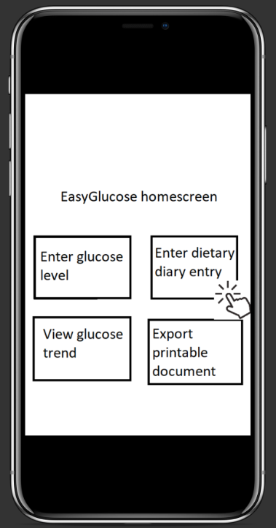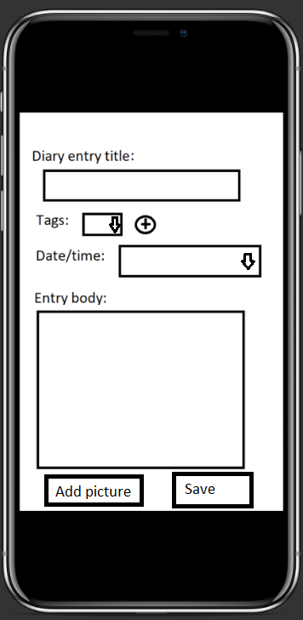

**Use case:** Exporting data to PDF.

1. **Use case:** To export the saved glucose measurement data as PDF, the user need to travel to the EasyGlucose home screen by swiping right.
2. Once the user reached the home screen, can find a large button named “Export printable document”. This button will have a “?” bubble beside it. The user can click the bubble to read a description for the use of this feature. (see figure 1)
3. Once the user tap the “Export printable document” button,the user will be redirected to the export document options screen. By default, the user be shown a graph showing glucose measurement for the last 30 days. (see figure 2)
4. To select the time frame of graph exported, the user can pinch or expand the graph to the appropriate time frame.
5. The user can also modify the time frame displayed by selecting given time frame options through the drop down menus. (see figure 2)
6. To choose a different time frame, the user can drag the graph to the left or to the right.
7. Once the user selected their desired options, they can tap the “Export” button at the bottom of the screen, which will show them the target export location screen. The export process is complete once the user selects their desired target export location.

Figure 1 Figure 2

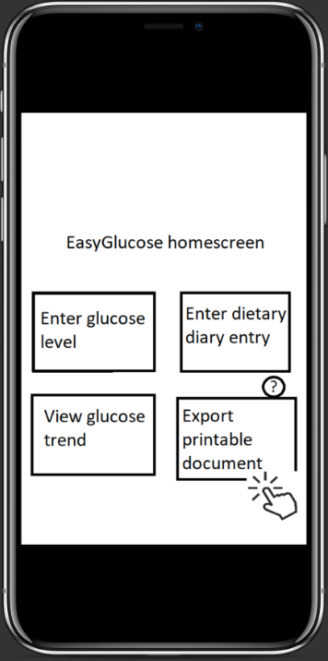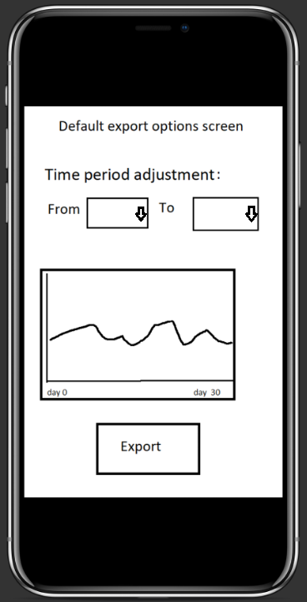

**Use case:** Application Onboarding

Onboarding experiences are an important aspect of any application. It is a process of integrating a new user into our app. As our application is intended to be used by older and mature population segment, it is important to make the onboarding experience as intuitive as possible. We aim to guide our users through every step of the way within our app.

In order to accomplish our goal of anyone being able to use our app, regardless of technical skills or know-how, we have designed a friendly and personified onboarding experience to the app. This should give our user’s the impression that our app is personalized for them.

Here is the onboarding user-interface we have designed as a stepping stone for users before they start using our app:

Figure 1 Figure 2 Figure 3

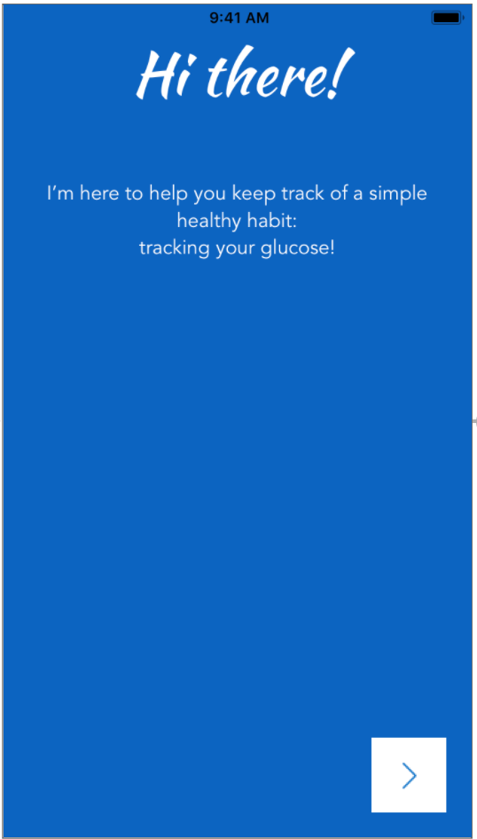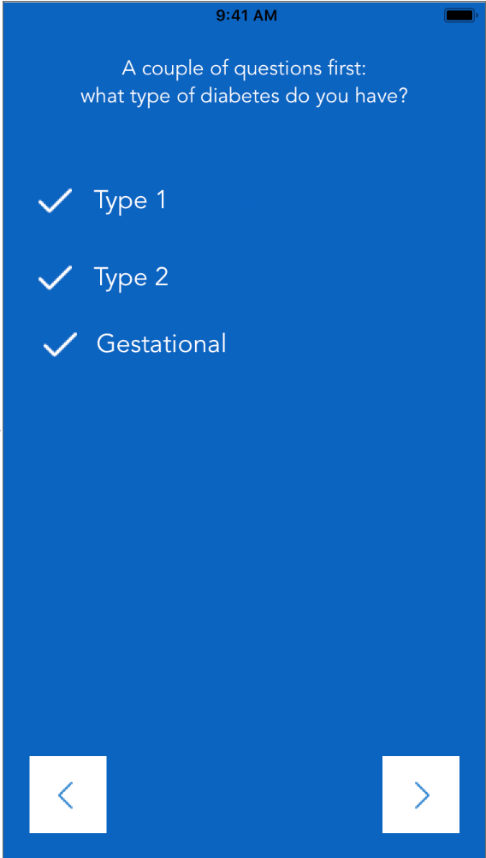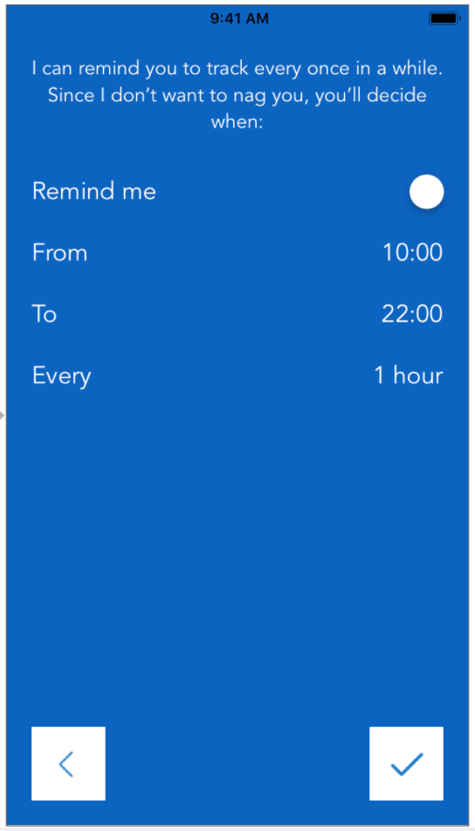\

**8. Glossary**

**App Store:** Digital distribution platform by Apple Inc. where owners of their products can purchase and download applications.

**Blood glucose level:** Concentration of sugar within the blood.

**Drop down menu:** A menu list of items that appears when the drop down menu is expanded. Users interact with the items by selecting them by tapping them.

**Exporting:** The act of converting a digital file into another format.

**Functional Requirements:** Project requirements that provides the function or behaviour of a system, its inputs and outputs, and the actions the project must execute.

**Gestational diabetes:** Condition when women develop high blood sugar during pregnancy.

**Gestures:** A set of various methods to interact with the mobile device’s touchscreen. Users operate these gestures by touching the screen (e.g. swiping up, double tapping, etc)

**Home screen:** The first page that is displayed when the application starts.

**Non-functional Requirements:** Project requirements that provides criteria to evaluate the system (e.g. security, stability, response/load times, performance, etc)

**Onboarding:** The action of familiarizing the user to the app.

**PDF(Printable Document Format)**: A file format where documents with text and images are saved such that it could be viewed, and printed.

**Pre-diabetes:** A condition where the blood glucose level is consistently higher than normal. Typically considered a precursor to type 2 diabetes.

**System testing:** Procedure in which several components of source code is compiled together and tested together with a sample set of data.

**Type 1 diabetes:** a genetic condition where the patient’s pancreas stop producing, or is producing minimal amount of insulin.

**Type 2 diabetes**: a disease where the patient’s body cells are resistant to insulin.

**Unit testing:** Procedure in which individual units of source code is applied with a sample set of data to produce results, evaluating the correctness of the results, and fixing errors with the code.

**Use case:** A description of how a user would typically use certain feature of an application as well as the possible mistakes the use might make.

**User interface:** How the user interacts with the software

**iOS:**  A mobile operating system used by mobile devices designed by Apple Inc.

**iPhone:** A mobile device released by Apple Inc on June 29, 2007.

**9. Citation**

[1]"Diabetes, by age group", *Www150.statcan.gc.ca*, 2018. [Online]. Available: https://www150.statcan.gc.ca/t1/tbl1/en/tv.action?pid=1310009607. [Accessed: 23- Jun- 2018].

[2]A. Favaro, "Tapping into technology helps seniors stay sharp", CTVNews, 2018. [Online]. Available: https://www.ctvnews.ca/health/health-headlines/tapping-into-technology-helps-seniors-stay-sharp-1.851670. [Accessed: 23- Jun- 2018].

[3]"Google Trends", Google, 2018. [Online]. Available: https://trends.google.com/trends/explore?date=2008-05-01%202018-06-22&q=diabetes%20app. [Accessed: 23- Jun- 2018].

[4]"List of iOS devices", En.wikipedia.org, 2018. [Online]. Available: https://en.wikipedia.org/wiki/List_of_iOS_devices#cite_note-5. [Accessed: 23- Jun- 2018].

[5]"App Store Review Guidelines - Apple Developer", Developer.apple.com, 2018. [Online]. Available: https://developer.apple.com/app-store/review/guidelines/. [Accessed: 23- Jun- 2018].